From a biological point of view, the 23.5 inch height limit is far too restrictive to be consistent with sexual dimorphism in the species. This is only a 4% difference between the tallest allowed doe height and the tallest allowed buck height. Data have shown that in dwarf goats, sexual dimorphism could be expected to be 15-30% (http://docsdrive.com/.../medwelljo.../javaa/2006/891-893.pdf). The height limit was originally chosen to fit a registry where an over height animal could legitimately be used for breeding, he could just not be shown. We have not made any serious attempt to reconcile the standard with either biology or the different rules of the registry we now find ourselves in. As long as we have does that are 22.5 inches tall, we will continue to produce bucks that are taller than 23.5". If we continue to ruthlessly cull all over height bucks we will produce a trend towards smaller does. In the ten years we have been part of ADGA, this trend has already appeared. A linear regression of the trait mean for Nigerian height over 10 years yields y = 24.8 - .3 x which says the mean height score has decreased over that ten years. The correlation coefficient for this linear relationship is -.8, which is consistent with a strong linear relationship. This says that when you look at the fitted line, we started out with a mean linear score of 24.8, and we would expect next year (11 years out) to see a mean linear score of 21.5. This is a decrease of the mean height of the breed of 3 points or .6 inches over 11 years. (regression from http://www.alcula.com/calculators/statistics/linear-regression/, data from http://www.adgagenetics.org/LinearTraitTrends.aspx, date range 2005 through 2015

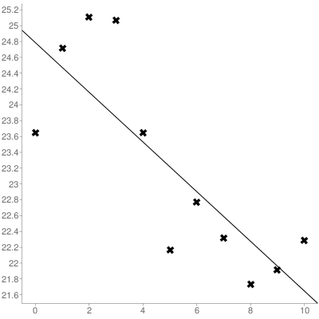

Sample size: 11
Mean x (x̄): 5
Mean y (ȳ): 23.216363636364
Intercept (a): 24.785454545455
Slope (b): -0.31381818181818
Regression line equation: y=24.785454545455-0.31381818181818x

